Bangladesh Army University of Science and Technology (BAUST), Saidpur

Department of Computer Science and Engineering



**Lab Report**

Course Code: CSE-1100

Course Title: Introduction to Computer System Sessional

Department: B.Sc. Engg. In CSE

Experiment No: 1

Name of Experiment: Write a C program to check whether a number is even or odd.

|  |  |
| --- | --- |
| Name: Nahid Hasan Arif  Roll: 220201075  Date of Experiment: 18.09.2022  Date of Submission: | Name of Teacher:  Designation:  Signature: ……………………………… |

**Name of Experiment:** Write a C program to check whether a number is even or odd.

**Theory**: A C program to check whether a number is even or odd. The number must be an integer.

**Code:**

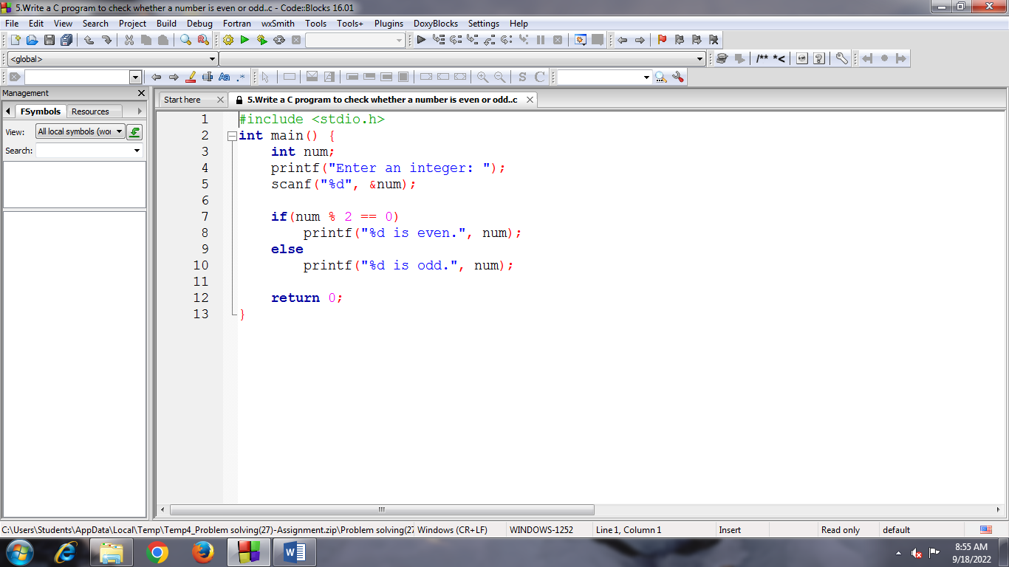

**Input:**

Enter an integer: 56

**Output:**

56 is even.

Process returned 0 (0x0) execution time : 1.744 s

Press any key to continue.